**OdinSchool Power BI Capstone Project**

**Objective**

Axon is a small size retailer company that sells scaled model vehicles. The sales team of the company do not have a centralized BI system to get accurate and analyze sales data for effective decision making.

**Data Source and Business Intelligence Setup**

Axon has an established database ‘classicmodels’ that captures all sales related data. The database schema consists of the following tables:

* **customers**: stores customer’s data.
* **products**: stores a list of scale model cars.
* **productlines**: stores a list of product lines.
* **orders**: stores sales orders placed by customers.
* **orderdetails**: stores sales order line items for every sales order.
* **payments**: stores payments made by customers based on their accounts.
* **employees**: stores employee information and the organization structure such as who reports to whom.
* **offices**: stores sales office data.

This database is hosted on MySQL server on Azure SQL database. The advantage of maintaining a cloud-based database is that it facilitates up to date data for the BI reports and better scalability in the future.

Login Credentials:

Server name: odinprojectserver.mysql.database.azure.com

Database: classicmodels

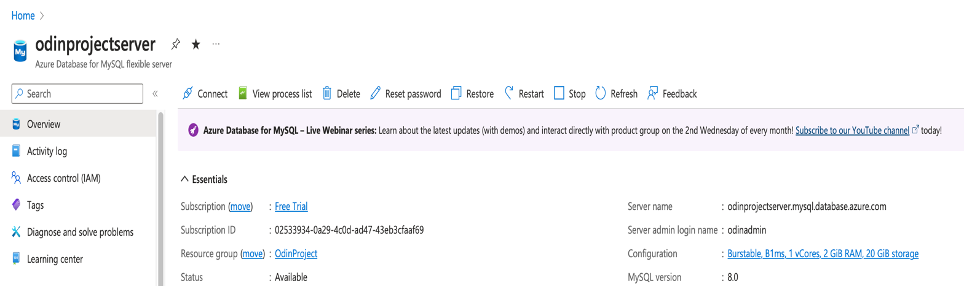

Power BI is the tool chosen to setup a BI system for centralized view of sales data. The tool is specifically chosen because it is an end-to-end BI tool that facilitates all the phases of a BI project from data extraction, data cleaning and prep, data modeling and report, dashboard and analytics development. Complex calculation that can’t be achieved with simple drag and drop of fields can easily be achieved using DAX language. Also, it seamlessly integrates with Azure database with less latency.

**Power BI Report**

The data model that is the foundation for the below report views is as follows:

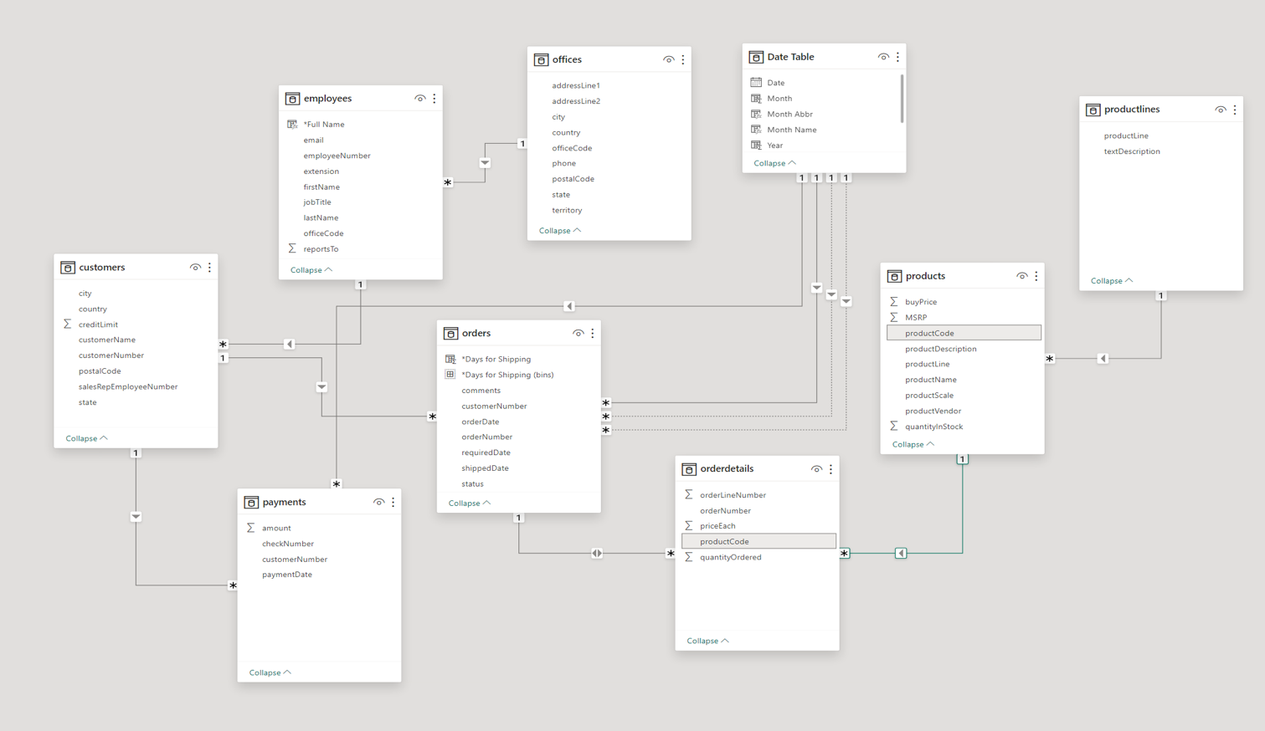

The Power BI report developed has two views:

1. Customer & Employee Analysis
2. Product Analysis
3. Customer & Employee Analysis View

The Customer & Employee Analysis view gives the users information such as total sales of orders by each employee, the customers they have served, the amount they have received for the orders, the pending amount to receive from the customers etc.

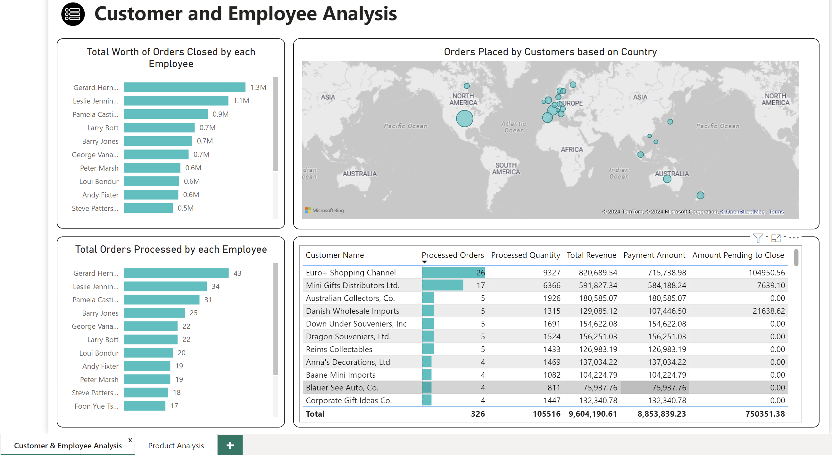

1. Product Analysis View

Product Analysis View is a comprehensive view that details about the percentage of product quantities ordered, revenue generated each month, distribution of days to ship etc. The gives a view on the most popular product, its quantity and revenue generated based on the total number of products sold.

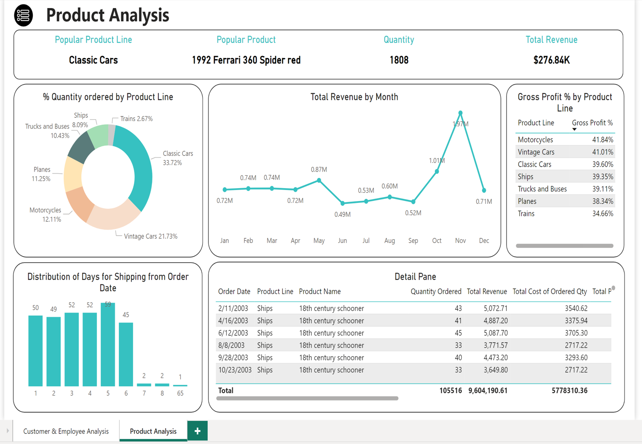

The Power BI report gives users more interactivity with the visual with the help of slicer panel. Users can slice and dice through the views by choosing different values of slicers and also by selecting different visuals. The below shown icon which is on the top left on each view drops down the slicer panel (Ctrl + Click).



The back button icon shown below minimizes the slicer panel.



**Report Analysis**

The Product Analysis Report gives a comprehensive view about the products and product lines.

The product that is most ordered or sold is ‘1992 Ferrari 360 Spider red’ with a quantity of 1808 sold between 2003 and May 2005. Even though this product falls under the ‘Classic cars’ product line which has higher sales percentage based on the units ordered, the product line that has the highest gross profit % is ‘Motorcycles’ with 41.84%. The report also checks for the distribution of the number of days it takes for the orders to ship out from the order date. As we can observe most orders get shipped within 6 days. We can observe an outlier order that took 65 days to ship the order. On drill down we can see that this is for the orders placed on 10/22/2003. These orders were on-hold because the customers’ credit limit exceeded. It is very evident that the company generates the most revenue during the month of November. This is to be assumed that most sales happen on prior month before the holiday season (December) starts.

**Suggestion**

The BI reporting system developed is better deployed in Power BI Service that provides a single source of truth for the entire organization and provides better security in the form of role assignment based on the users.